Addressing Water and Poverty at the Grassroots: A Case Study of Area Water Partnerships and Women and Water Networks in South Asia

Paper presented at Asia-Pacific Regional Consultation Workshop on Water and Poverty
Dhaka, Bangladesh, 22-26 September, 2002

Simi Kamal

Jasveen Jairath

First Draft

1. Poverty - Environment Nexus

In this decade some serious analytical work has been done on the idea of ‘entitlements’, and the linkages between poverty, population and environment (including water). This work shows clearly how women are consistently more disadvantaged than men.

Ownership of and access to land and water resources are key issues is preserving and using environmental assets and mitigating poverty. In South Asia, gender disparities distort access to land and water. While women continue to be responsible for much of the water collection and management of food production for household consumption, their limited access militates against food and water security. Existing social and cultural biases distort the intent of inheritance laws and the inadequacies of legal structures further limits ownership and control by women.

The poor, especially in rural areas, also tend to be more reliant on ‘common property’ resources to which everyone has access, eg forests, rangelands, water bodies and inshore fishing grounds. In south Asia where the worst poverty is concentrated, families draw heavily from the commons for their fuel, fodder and water. In dry land areas of India landless people derive a fifth of their annual income, together with a range of non-marketed goods, from the natural products of common areas. The ‘gauchars’ (land left uncultivated for grazing in honour of the revered cow and accessible for local people as common property) across the Indian sub-continent are an ancient method of protecting and rehabilitating environmentally marginal lands.

For women across South Asia, access to common property resources has been crucial in maintaining household water and food security. For example the disappearance of mangroves have destroyed the livelihoods of women and impoverished many Bangladeshi coastal households. While women in the region have traditionally managed agricultural activities, and have proven time and again that they are more ‘credit worthy’ than men, they have access to only a tiny percentage of agricultural microcredit.

It can be seen that most countries in South Asia have policies or strategies either on environment (which also covers water), water, or both. Countries also have strategies and plans for the advancement of women, where there is reference to women and water. Many countries have policies on poverty, but rarely are the three (water, poverty and women) addressed together. In cases where there is some mention of gender concerns and perspectives, these are general (or sometimes related to domestic water, water transport on foot and water rights). Specific gender provisions relating to water (for example the role that women could play in preserving, regenerating or managing water bodies) are rarely seen, nor is there much in terms of women playing a role (as beneficiaries, users and managers) in plans to address the poverty-environment nexus.

However, it may be needed that there have been instances of some projects across South Asia where women have played a proactive role in managing water in ways that have addressed poverty indirectly, but without reference to national or provincial policies and strategies. For example a university department near Bombay, in India, has created 17 artificial lakes through rainwater harvesting and ecological regeneration in a local area, using abandoned quarries. The designers and implementers are all women – from the university and local women. In the same way local women and children in a project in Sindh, Pakistan, regularly cleaned up and maintained the flow of drainage channels, helping to keep the irrigation and drainage channels separate.

For the poor in South Asia, ‘poverty reduction’ means water, food and livelihood security. Platforms for action that include women are needed to manifest and validate critical needs and priority areas for the promotion of water, food and livelihood security in the region (the three cornerstones for poverty alleviation) particularly at the grassroots level. The following two cases (one from Pakistan and one from India) illustrate how participatory platforms at grassroots level are attempting to tackle the issues of water, food and livelihood security.

Addressing Poverty in a Delta Region:

A Case from Pakistan

Historically the River Indus discharged into the Arabian Sea via a huge delta with 14 main mouths known as creeks. The Indus Delta consists of 1.5 million acres of land (from Karachi to Run of Kachh), and a population of about 1.5 million people, of which 0.5 million are fishermen.

Pakistan Map Showing
Indus Area Water Partnership’s
Area of Operation
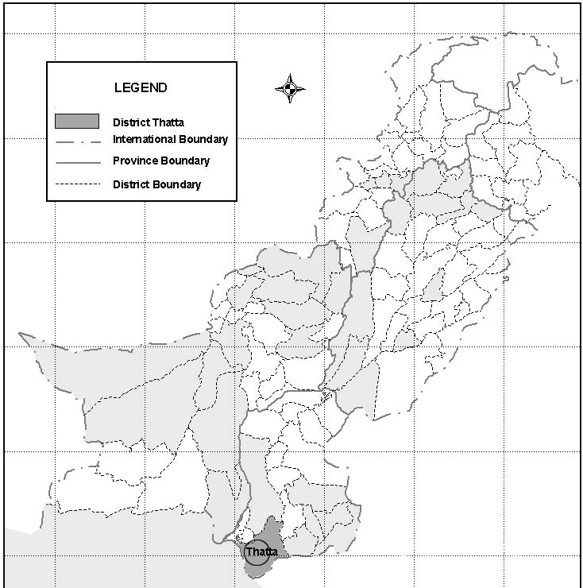

The drying up of the River Indus downstream from Kotri Barrage has permanently damaged the ecosystem. It is established that the sea has intruded up to 150 miles (about 225 km). Shrimp production has decreased to one-tenth. The mangrove forest which covered 0.6 million acres has been reduced to 0.25 million acres. The drying up of the Delta and the subsequent decrease in shrimp and fish production has affected the livelihood of a vast majority of nearly half a million fishermen in the region.

While the realities of water availability, it’s regime, the climate, weather, delta conditions and the market have changed, the way of managing farms and using water at farm level has not. About 45 % of the land area is under cultivation. Poor management and distribution of irrigation water has also rendered a large area of land uncultivable and resulted in low crop yield and thousands of local farmers whose livelihood depended on agriculture are facing economic hardship. Poverty is on the increase.

Findings of a recent research study conducted in five districts of Sindh (including the case study areas) showed that all people earning Rs 6,954 (US $ 117) or less per month can be classified as poor. Table 1 shows the proportion of households in district Thatta (a large part of which is covered by the Indus Delta Area Water Partnership) that had annual average per capita incomes below the food poverty line, in five major categories: small farmers, haris, wage laborers, fishing and livestock families. It can be seen that 56 percent of all households were below the poverty line (that is more than half of the households).

Table -1
Households with Average Annual per Capita Incomes Below the Food

Poverty Line in Indus Delta Area (District Thatta)

 | Small Farmers (%) | Share  Croppers  (%) | Wage Laborers  (%) | Fisher Folk  (%) | Livestock  (%) | Total  (%)
Households with average annual per capita income below in Pak Rs 6954 (US $ 117) per month | 67 | 48 | 63 | 49 | 100 | 56
Source: Sindh Rural Development Project, P&D, GoS/Asian Development Bank / Raasta / Agrodev, 2000

Using the US$1 poverty line, for all households in the sample, gives an even higher proportion of poor households. When the US$ 1/person/day formula (where US$1 = Rs 59.25), was applied, it can be seen that all the households that earn up to Rs 5,000 (US$ 84.38) per month were well below the poverty line. This means that 67 percent of the households ( ie two thirds) were below the poverty line in the Indus Delta AWP area. In fact even the families earning Rs 10,000 (US$ 169) per month (US$ 0.8 /person/day) are just on the margins of the poverty line. The low proportion of earning members reinforces the dependency ratio, which is another indicator of poverty.

The Indus Delta Area Water Partnership was initiated in June 2001. as part of the work of the Global Water Partnership (GWP). Its main objective is to promote water, food and livelihood security (and thereby tackle poverty). Its members include local NGOs, government departments and national-level support organizations as well as local farmers and stakeholders

The long term vision of the partnership includes:

Revitalizing of the Indus Delta: eco-system, coastal rejuvenation, agriculture, fisheries, economy and social development.

- Transformation of the water sector into an integrated sector with complete coordination between the various departments and agencies working in the sector and availability of institutions that addresses the water related problems of the area, thereby promoting water, food and livelihood security.

Some relevant components of Indus Delta AWPs’ 10-year Vision are:

- Development of model water management in the Indus Delta by using innovative and practical approaches under Integrated Water Resources Management (IWRM). Equity considerations will include the allocation of water head and tail users and to all sections of society (particularly the poor and landless).

- A system of cost recovery that not only pays for itself but also generates surplus revenue for economic and social development.

- A minimization of conveyance losses in the irrigation system, efficient irrigation practices and move to more efficient use of water through changes in the cropping pattern.

- Increase in crop production (while using lower inputs of water) to address water and food security.

The first milestone is a model distributory (Mirpur Sakro Command Area) that is planned and managed through full participation of the stakeholders. In this vision, farmers’ institutions will be strengthened and farmers’ capacity for improved practices will be enhanced.

Area Covered by Indus Delta Area Water Partnership (IDAWP) in First Phase
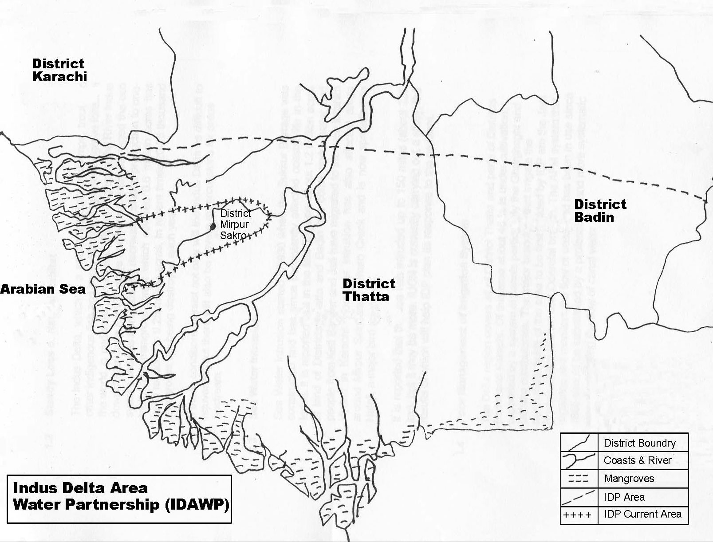

This grassroots effort at addressing food, water and livelihood issues (and thereby addressing poverty) is now attempting to ‘genderize’ its work, by institutionalizing Women and Water Network as a parallel and mainstream initiative.

Gender mainstreaming, is a necessity to ensure that the water issues (as well as poverty equity and justice issues), policies, strategies, programmes and actions are discussed, planned and implemented in ways that most support women and where the adverse impacts on women are minimized or curtailed.

The WWNs have been designed strategically as women’s only platforms (that will also bring the strengthens of the institutions its members represent), until such time that there is 50 percent representation of women in all levels of GWP and its family of institutions in South Asia.

Within Indus Delta AWP the approach at gender mainstreaming remains strategic – a separate WWN to activate women’s issues, and WWN members on the steering committee of Indus Delta AWP.

The WWN working with Indus Delta AWP essentially addresses the need for empowering women to effectively participate in Area Water Partnerships. It envisages networking of women and women’s organizations working with water related issues, and their "capacity building" for handling water issues effectively, from a strong gender perspective. They are also eventually expected to influence policies, plans and actions in the eater sector, and to promote gender-sensitive integrated water resources management (IWRM).

The WWN functioning with Indus Delta AWP has 15 members at present.

The functions of WWN programme at IDAWP level have been clearly laid out and reflects the functions of national WWNs at grassroots level:

- Identification of women members and women's organizations that can form a women's perspective on water, and highlight (as well as seek to address) those issues that particularly affect women in the area.

- Women leaders in water
- Gender and water specialists
- Active water professionals
- Women and water organizations
- Women with interest in the water sector

- Strengthening the role of women and women’s organizations in the planning, development and management AWPs

- Promotion and strengthening of empowerment of women in relation to water resource management at grassroots level.

- Institutionalization of gender analysis and gender audit at all in all of policy, planning programmes and project implementation works of AWPs

- Ensuring the implementation of women focused approaches and budgetary allocations in AWP initiatives and programmes in water, food and livelihood security.

- Case from India

The case study refers to a proposal for action for capacity building for women water sector professionals through introduction of innovations in higher education for water resource management in South Asia. There is a widespread consensus for the need to shift the water paradigm from the engineering and technological dominated one to an interdisciplinary perspective that integrates the technical and specifically social/institutional concerns. While this need for a change of viewpoint is well acknowledged the – practical concerns of operationalising the same create the need for a future generation of water sector professionals who are educated in the new tradition – a tradition that addresses itself to the requirements of organic integration of the water sector with other technical and social disciplines. he new issues that need to be integrated are ecological sustainability, institutional dimensions of WRM, gender issues , IWRM and the like. Proactive action is required to taken to nurture such a community of IWRM professionals – which is absent as of now. The action proposed is an attempt to respond to the above challenge.

The main set of activities will include piloting the higher education program for capacity building for IWRM, in selected institutes from each of the South Asian countries. Support is to be provided for research grants for students for postgraduate studies – possibly Masters or diploma or short-term courses, Ph. D. level or short research support on issues of IWRM in the region that will feedback into the curriculum development for the education program.
Secondly, design of new courses and development of the course material will be undertaken in the context of South Asian water problems and issues.
Thirdly, capacity building of resource persons for teaching the program will be a major activity during the initial phase of the program – it will be initiated by creating a central pool of excellence from among existing water sector professionals who have undergone additional education in the IWRM trajectory.

Fourthly, the program envisages a strong networking activity through periodic workshops/ seminars at the regional level in order to encourage a specifically South Asian perspective on water as opposed to a more national one – specially in the context of transboundary water issues.

Finally, the program proposes to have a special bias towards involving women professionals – both as students and as resource persons so as to have a higher visibility of women in senior professional capacities in the water sector in future. A conscious and deliberate tilt in the favor of women participants is built into the program.

Currently, the program is at the stage of evolving a consolidated proposal for South Asia in consultations with the various partner institutes in the region.

An appendix of the main activities of the project is attached for further reference.

4. Conclusions

To focus on the needs and aspirations of women requires a re-examination of water, food and livelihood security issues within the poverty-environment nexus. Empowering women and men (and communities) to conserve the quantity and quality of freshwater and terrestrial ecosystems (that provide services to humans and all living things), must be the hallmark of all 'engendered' poverty-alleviation efforts at grassroots level. The instances of the Indus Delta WP and ….(case from India) shows that gender mainstreaming, strategic gender inputs, a focus on food and water management and capacity building within local participatory institutions can address poverty in South Asia.

The concept of ‘ Entitlements’ are best discuss in L Melissa & Mearns R, “Poverty and the Environment in Developing Countries: An overview Stud, ESRC Society and Politics Group / GECP and ODA, 1991
For details see “Rural Women and Food Security” – Current Situation and Perspectives, FAO, Rome, 1998
For details see “ Effects of the Interplay of Different Formal and Customary Laws on Women in Pakistan” 2002 Simi Kamal, et al
For details see Poverty and Environment Chapter for: State of the Environment in Asia and the Pacific, 2000 by UNESCAP 2000
“Vision and Programme Document”, Indus Delta Partnership (IDP), December 2001
“Sindh Rural Development Project, Household Survey Report”, P&D-GoS/The Asian Development Bank/Raasta Development Consultant/AGRODEV, February 2000
The food poverty line was calculated using the national minimum calories requirement of 2,550 calories per capita per day. This is approximately equivalent to Rs 6,954 (US $ 117) per capita per annum for Pakistan. “Sindh Rural Development Project, P&D-GoS/ADB/RDC/AGRODEV”, February 2000, pp 30-35
There are many measures of poverty. The two most commonly used measures are the food poverty line (mostly used for establishing national poverty lines) and the dollar a day poverty line (mostly used for making international comparisons). The food poverty line is the level of private consumption per person at which minimum calorie requirements, plus a small allowance for non-food consumption, are just met. It is typically expressed in terms of per capita per annum.
The dollar a day poverty line defines a minimum level of private consumption. It is typically US$1 per person per day, adjusted for purchasing power parity.
Given that the average family size works out to 6.8 in the sample household, the average monthly income per person ranges from Rs 147 (US$ 2.48) /month to Rs 735 (US$ 12.40) /month for those households that earn between Rs 1,000 – 5,000 (US$ 16.87- US$ 84.38)per month. The average daily income per person is in the range of Rs 5 to Rs 25 (US $ 0.084 – US $ 0.421).
A global movement to all bring all stakeholders in water on a single platform is currently underway, called the Global Water Partnership (GWP) with headquarters in Stockholm. Within the context of the emerging partnerships in water sector in South Asia (which include a Technical Advisory Committee, an emerging Regional Water Partnership, Country Water Partnerships and Area Water Partnerships)

