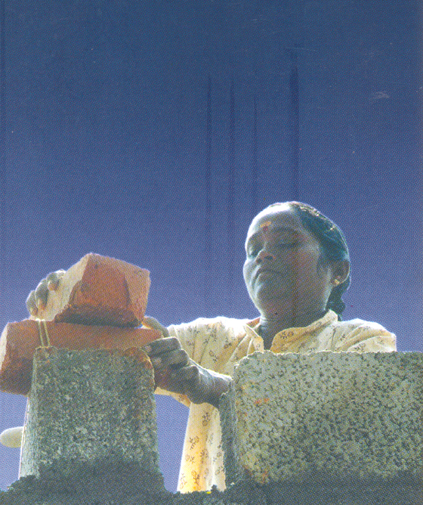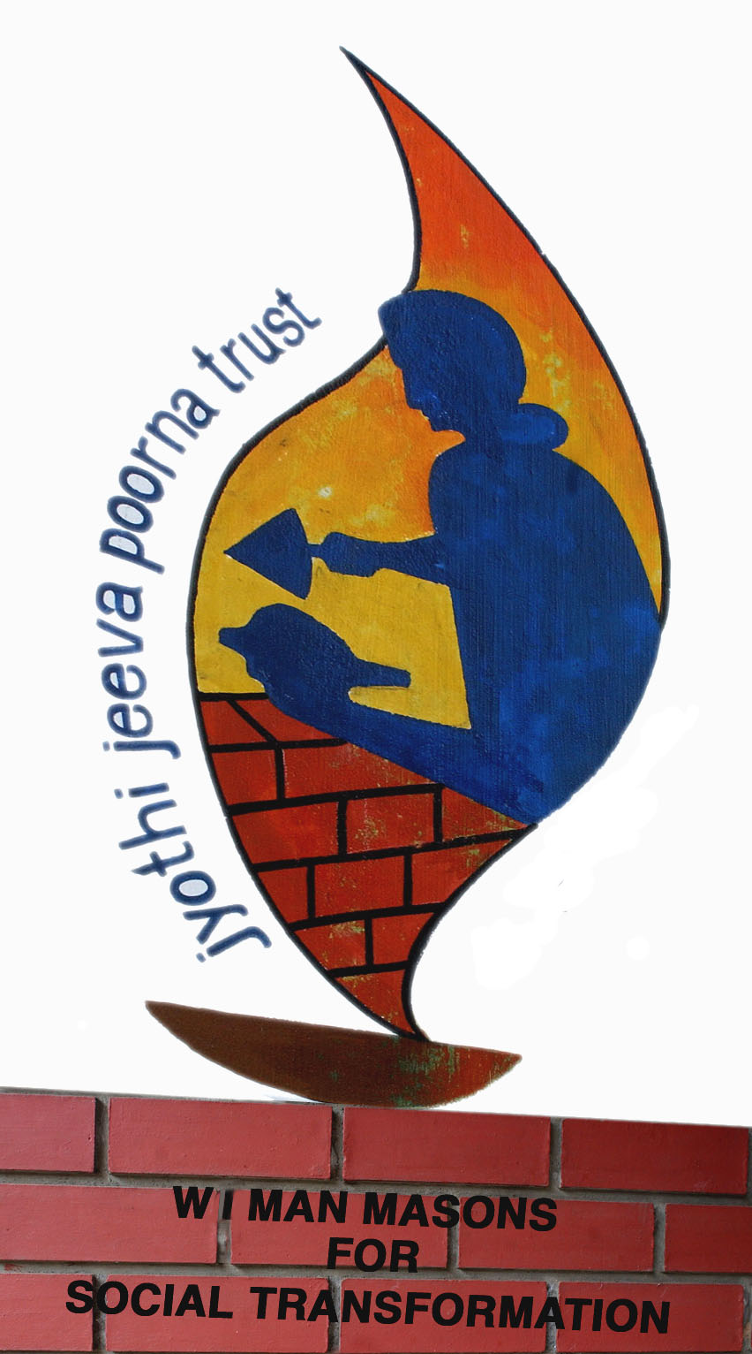

A CASE STUDY OF SUCCESSFUL INTERVENTION-

THE J.JEEVAPOORNA WOMEN MASONS OF KERALA

A presentation by Thresiamma Mathew and Jayasree P.K. at the Stockholm World Water Week on 22nd August 2006.

This is a case study, which emerged as a result of a Water-sanitation project and had tremendous impact on the destiny of women especially poor women. I only wish that it would inspire many to take similar steps to liberate the women from age-old bonds and segregations.

The genesis

In 1989 the story starts when 12 daring women who took the courageous step to train themselves as “latrine masons”.

The Dutch - Danish supported water supply and sanitation project was on its way in Kerala, India during 1987- 1994

Hundreds of latrines were being built in the rural areas as part of the project.

Women were seen everywhere assisting the skilled male masons but earning just one forth of the male mason’s pay.

I was moved by the hard toil, the low wages and the low status of these women. I thought the scenario would be different if they could acquire the skill of masonry and master the job themselves. Helper women always had a social stigma in the society. Perhaps that could also be lifted.

But translating my ideas was not at all easy- Why?

The Hurdles
- It was questioning the existing cultural laws and practices – Women were NOT to hold the trowel; it would become unclean. They believed that the Gods even would be angry
- Breaking the stereotype- the mind set of the women themselves
- The fear of ridicule and criticism
- The resistance from the males and religious leaders
- The existing demarcation of women’s and men’s jobs
[Even educated men like IAS officers, engineers and political leaders would ask me: “Can women climb?” They never noticed the women climbing up the temporary scaffolds with bags of cement or mortar during the multi story constructions!!! Only when they are mastering the trade and stands there more safely with the trowel every one became concerned “can women climb”? How gender blind!]

How could we break the “Male bastion Brick by Brick”?

- Through untiring Persuasion and motivation
- Through social training – building awareness and confidence in the women
- By convincing authorities and colleagues, and orienting the staff
- By finding a Gender sensitive male mason to accompany them
- By providing stipend during training so that they can go on supporting their families
- By sensitizing the local leaders and community
- By preparing a very well designed training programme with the help of engineers and sociologists to instill confidence and courage to face the challenges of such a cultural shock.
- Through appreciation and recognition given to the women pioneers by Dutch embassy, the Socio economic Advisor, the senior staff, and dignitaries of Dutch -Danish missions
- Ensuring social acceptance by providing a male mason in the team initially.
- Ensuring opportunity to employ their skills, gain expertise and earn a good income. [Continuous work was possible because of the sanitation scheme. Making hand made bricks, concrete door window frames, jollies etc helped to reduce the cost of latrines and earn better]
- Through support of the media – news papers, Television, radio, magazines - both national and international
- Through national- International recognitions
- Women becoming ready to cope with the challenges and opportunities [When sanitation project ended they diversified into many other construction related skills like housing, Ferro cement technologies [mainly for rain water collection tanks] concrete hollow brick production units, [operating machines, mind you! No One wanted to train women to operate the machines. A male operator could earn Rs.150.00 per day while the women who mixed the mortar and fed the machine would receive Rs.75.00!] Plumbing, carpentry, aluminum fabrication, water meter repair, pre-cast materials etc.]
- By registering them legally
- Through the good leadership within the group and their unity
- Through the support of the parental body.

How did it get mainstreamed?

- Through the interest shown by the Dutch Embassy to spread the story to other parts of the country and countries and promoting it.
- The World Bank, UNICEF and such other International agencies incorporated it in their projects for women’s empowerment. So much so that it became a rule that any watsan project should give equal opportunity to women and men in all the training and jobs arising in the project.
- The state & local Governments accepted and promoted it as a strong means of women’s empowerment along with many NGOs in the state and outside the state. [like Nirmithi Kendra, Maitry, Gram Vikas Kerala & Orissa, SEWA Gujarat etc.]
- This experiment paved the road for the entry of women into many more male –only occupations like drivers of auto rickshaws& buses; conductors, managers of canteen and restaurants, factories of concrete block production etc.

Achievements and impacts on the women masons

- Dignity, confidence, sense of worth, recognition at home and society.
- Equal pay for equal job
- Earns better; has a voice at home, can make decisions and influence family decisions
- Initiating their husbands too in to the trade and jointly taking up contracts [for social security]
- Improvements to their own houses
- Networking with women’s groups
- Courage to travel, face unknown people and situations, address a gathering, marketing, managing etc.
- Lot of exposures, visitors
- Participation in the tsunami reconstruction of houses & many more……..
[Special note: One group from Kottayam expressed their solidarity with the tsunami affected group of women masons in another district, Kollam, by going and staying with them and constructing one house as their contribution!]

In-spite of these why is gender mainstreaming so hard?

- It is a donor driven concept. Implementers and agencies accept it just because they have to.
- The environments in which the water projects operate have not changed much. [The culture and practices in a given society, the other departments. The few gender sensitized males might get cornered] Trained officers, politicians etc. get transferred, and there may not be always provision for training in gender or they don’t turn up for the training]
- Equality, Equity, Justice etc. are seemingly threatening to the male dominated world and they resist it out right [Eg. Women’s reservation bill of Indian Parliament]
- Fear of disturbing the existing power relations
- Gender awareness is making demands on the male to share more burdens, where as he is used to enjoy an advantageous position; this he does not want to give up.
- Women folk however sensitized, want the security of a home and the good of their children; so they yield to male and social pressures and religious norms.
- Many agencies conduct women empowerment programmes just for the fact of availability of funds. And they “do” it for reports and not for change.

