A Gender Sensitive IEC Campaign for Disaster Risk Management

Abstract:

The project entitled Geohazard Assessment and Mapping aims to generate information through geohazard susceptibility maps, in particular flooding and landslide susceptibility maps. One of the emphasis is to provide women and men with equal access to information that would indicate susceptibility of pilot communities. As women are badly affected by geohazards as landslides and flood, providing them with information as to the susceptibility of their communities is one way to help them cope better in times of such natural hazards. A gendered approach to information, education and communication ensures that women and men will have equal access to geohazard information, enabling them to understand the risks involved and helping them manage disaster at the community level. Disaster risk reduction management should aim to provide access to information to both women and men, empowering them and enabling them to recognize their roles and relevance to participate actively in disaster risk management efforts at the local levels.
While integrating gender concerns in disaster risk management such as geohazard survey and assessment is difficult to achieve, inclusion of a gendered IEC component focused on providing equal access to information has helped integrate women's and men's concerns in the technical aspects of the project. Lesson clearly pointed out to the importance of a gendered IEC campaign and it should be a part of any disaster risk management program. Real empowerment of vulnerable communities to manage disaster at their levels can be achieved by providing equal access to information to women and men, information that would spell out the difference in their survival in times of natural disasters.

Key words: geohazard, landslides, flooding, hazard maps, gendered IEC
Introduction:
The geographic location of the Philippines, being within the circum pacific rings of fire, renders it highly vulnerable not only to natural disasters that are geologic in nature such as earthquake, volcanic eruptions, but also makes it susceptible to climatic variability causing tropical cyclones and floods. Because of this, Philippines has to contend with geological hazards (or geohazards) most of the time. Geological hazards or geohazards are natural hazards which result from geological phenomena. These could be endogenous in origin (such as earthquake and volcanic hazards) or exogenous in origin (such as mass movement or landslide, floods, accelerated erosion and drought.

In the 2004 global report of the United Nations Development Programme (UNDP), Philippines ranked as the third in terms of number of people exposed to earthquake and tropical cyclones annually. The same report places the country with the highest frequency of tropical cyclones with reported deaths. Uncontrolled human activities such as settlements in the flood plains, urban congestion and development activities in the uplands have exacerbated the impacts of natural hazards. Based on reports compiled by the (Philippine) Office of the Civil Defense for the period 1990 to 2001, the total damages from natural disasters was estimated to be US$3 B. This means an annual average damage to property of US$ 259 M. However, it must be noted that this figure considered only direct cost which means that the total actual damages brought about by natural disasters could be much, much higher. It is worthwhile to note that a considerable amount can be attributed to damages caused by flooding and landslides directly resulting from tropical cyclones.

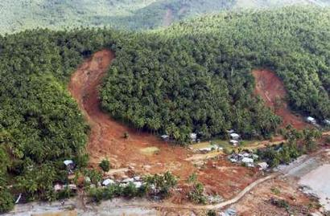
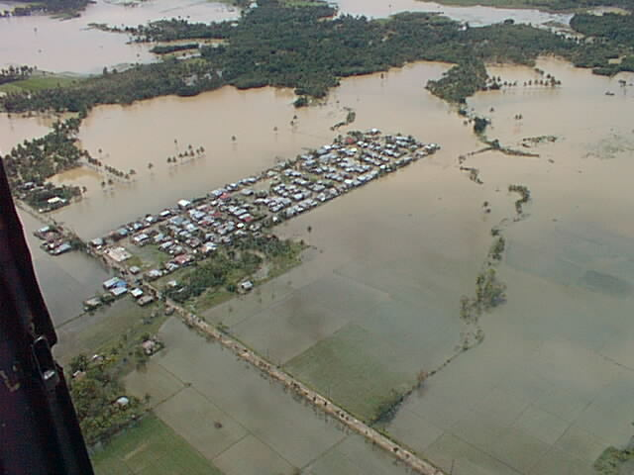

Figure 1 : Samples of water-related hazards such as flooding and landslide in the Philippines ( Photos courtesy of Mines and Geosciences Bureau, DENR)

The landslide that occurred in Panaon Island in Southern Leyte and in Surigao City in 2003 has prompted actions for the need to address geohazards with focus on water-related disaster through the conduct of a systematic geohazard assessment and mapping of areas susceptible to such phenomena. Both Southern Leyte and Surigao City were located in that part of the country which are subject to extreme rainfall condition that often trigger mass movement or landslides and flashflood. While the threat of landslide and flashflood in these areas may have periodically subsided, the instability of these and other contiguous areas due to its geologic composition and the amount of rainfall it receives remain and would continue to pose threat to the local population. It has become imperative to conduct a systematic geohazard assessment and mapping to identify unstable sites so that appropriate measures can be instituted. Being a tropical country with an annual rainfall of more than 2,000 millimeters , the Philippines has to contend and cope with the reality that water is both a benefit and a major threat to the lives of thousand of Filipinos. Flooding often results from heavy rainfall. Excessive rain almost always trigger landslides in high and sloping areas.

The Project Initiative
In 2004, the Department of Environment and Natural Resources (DENR) and the Mines and Geosciences Bureau (MGB) implemented a project on geohazard assessment and mapping with emphasis on water-induced hazards. This undertaking was made possible through assistance from the United Nations Development Program to address problems of natural disasters, especially those that are triggered by water in the form of excessive rainfall. Thus, a study on the development of a mitigation scheme for geological hazards was undertaken as part of the Environment and Natural Resources (ENR) Shell Programme. The study was intended to generate information on the vulnerability of portions of the selected pilot areas (mostly along the Philippine eastern seaboard) to natural hazards like landslides, flooding, subsidence, coastal degradation, tsunamis, earthquake and similar geologic events. The intention was to make these information available to decision makers, planners and other national and local authorities. These information were transformed into susceptibility maps that provided basis for land use planning and development and more importantly for disaster management and risk mitigation. The study was also designed to better prepare both local government units and local communities to manage and cope with disasters and risks related to geological hazards by educating and informing them of the susceptibility and vulnerability of their communities.

The Project Approach

The approach involved the characterization of various events in terms local conditions ( past occurrences of landslides, flash flooding, subsidence) and the identification of areas or sites susceptible to different geologic and water-related events. The main concerns of the project were flooding, rain-induced landslides and other mass movements, subsidence, ground instabilities and coastal storm surges. Furthermore, actual flooding surveys and landslide inventory were also conducted with the communities as provider of information. These were done using survey questionnaire and checklists. In addition, collection of soil samples were also done with soil samples brought and analyzed in the soils laboratory.

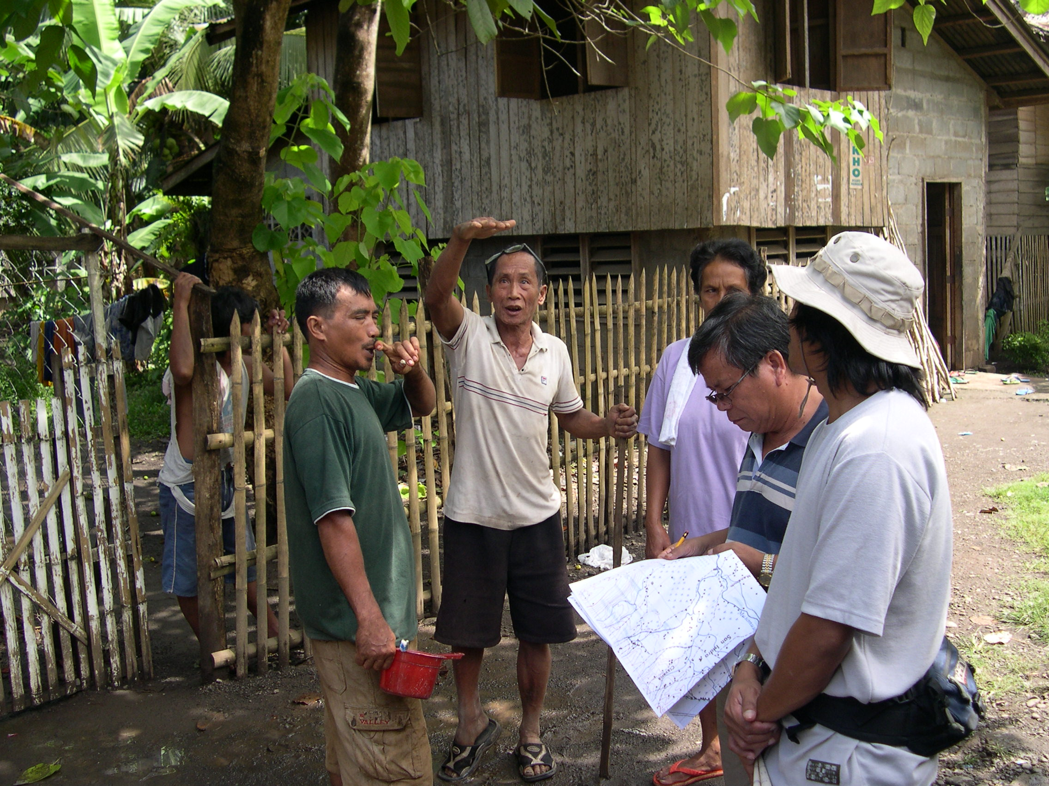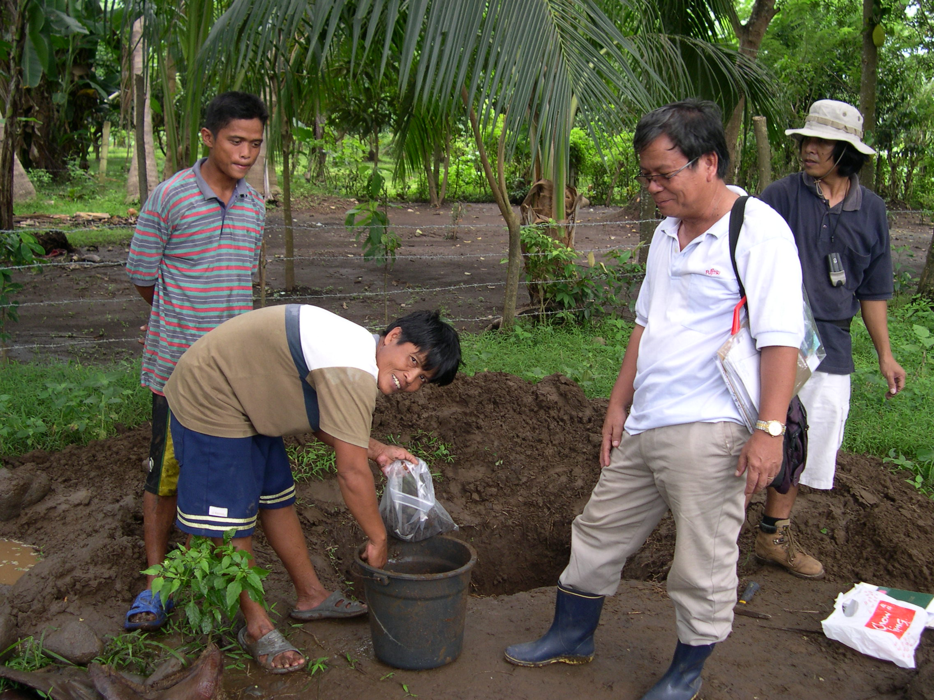

Figure 2: Photos showing interview with local population (Photos courtesy of Mines and Geosciences Bureau, DENR)

The project also made use of Geographic Information System (GIS) to collect, manage and analyze data in order to come up with the geohazard maps. There were six (6) regional pilot areas selected on the basis of landslide and flooding events being experienced as well as criteria such as population and extent of growth and level of economic development. The selected pilot areas for the project were: Easter Rizal, Panaon Island, part of the Naga and Legazpi City, the Cagayan de Oro-Gingoog coastal strip, part of Tagum and Davao City as well as part of Surigao and Butuan City.

The production of the 1:50,000 scale geohazard maps were accomplished using GIS desktop mapping. The methods used were based on the standardized procedures developed by the Mines and Geosciences Bureau (MGB) of DENR on Geological Hazard Maps Production for the entire country. Its production method purely involved the compilation of existing and available data, conversion to digital format and analysis using the Integrated Land and Water Information (ILWIS) software. Data were arranged into organized themes and each theme was further classified according to its attribute on the basis of susceptibility to a specific hazard type.

The production of the 1:10,000 scale geohazard maps involved interpretation of aerial photographs and satellite images and detailed geohazard field mapping of selected areas. The high risk areas delineated at 1:50,000 scale geohazard maps were prioritized for detailed ground mapping at 1:10,000 scale. Additional output in this mapping scale are suitability maps for human settlements in selected areas.

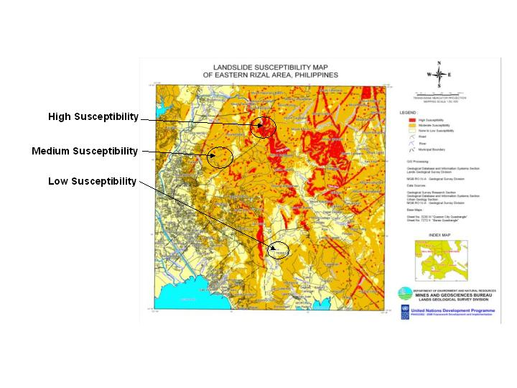
Figure 3 : Sample of landslide susceptibility map prepared by the project(Courtesy of Mines & Geosciences Bureau, DENR and ENR Shell Programme)
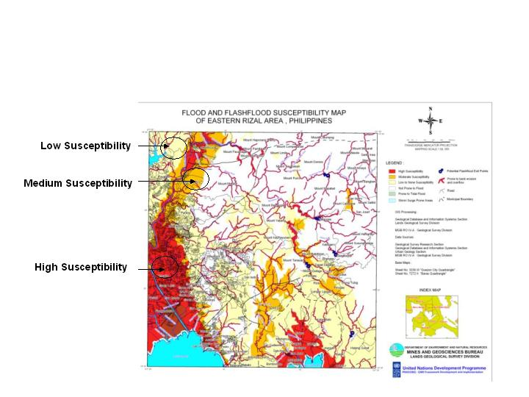

Figure 4 : Sample of flooding susceptibility map prepared by the project (Courtesy of Mines & Geosciences Bureau, DENR and ENR Shell Programme)
The Gendered Approach to Information, Communication and Education (IEC) Component of the Project

There were two (2) main target of the information, communication and education (IEC) campaign of the project: the local government units (LGUs) and the community itself. The Information and Education Campaign (IEC) on water-related hazards was conducted in the pilot areas . The project recognized the important role of the Local Government Units as partners in the management of water related disaster. Thus, the IEC activity focused in engaging the LGU by building a closer relationship with the local government units within the pilot regions and sites. Coordination with the local government units, in particular the local engineering departments/units and the municipal planning and involved them in the series of meetings and discussions was a major feature of the project.. Data from the municipality on flooding and landslide incidents in the past years were collected and analyzed.

Target participants from the LGUs include LGU heads such as the governors, mayors and barangay chairmen as well as staff from the LGUs. The primary objective was to inform them on the reality of water-induced hazards such as flooding and landslides and educate them on mitigation measures to cope with such hazards. During the said seminars/workshops, experts were invited to discussed in detail the data and. The LGUs were also taught to understand and use the geohazard maps as guide to local comprehensive land use planning and zoning. To ensure the use of the geohazard maps in local development planning, copies of the geohazard maps were produced and distributed to the municipalities concerned. A compact disk (CD ) containing the said maps with explicit information were also produced for the LGUs including a CD on geohazard for information, education and communication (IEC) campaign purposes The IEC CDs which were prepared originally in English, were translated in the local dialect to make it more useful and understandable to the local people. Furthermore, part of the advocacy campaign and in coordination with the LGUs concerned, was the placement of warning signs in English and in local dialects informing the community as to the susceptibility of certain areas within the locality to water related hazards, in particular, those that are highly prone to landslides. The signages are expected to impart information and serve as a reminder to the community as to the threats of building houses within such areas.

The other important target of the IEC campaign was the community resident themselves. Experience showed that almost always when disaster strikes such in the case of flooding and landslides, the first to be affected are the local population or residents that actually lives in the community that are highly prone to such disasters. It is therefore logical that the community as a whole should be regarded as the first line of defense for such water-related calamities. The readiness of the communities and their capability to cope with flooding and landslide need to be built up, strengthened and sustained. Thus, the involvement of local communities in managing water related hazards is not only critical but a vital aspect of water-related disaster management programs. In the case of the project, community involvement was made explicit in the project by the active participation of the communities in the provision on relevant information on floodings and landslides that were captured and collected during the conduct of the community survey and assessment. As respondents to the survey questionnaire, the community has provided the project with valuable information that were used in the preparation of hazard maps. Furthermore, the community also provide assistance in the collection of soil samples that were analyzed to provide additional primary information for the preparation of soil profiles.

The communities were specifically targeted for the conduct of the information and education campaigns. Men and women from the communities actively participated in the information drive activities. Using mainly the flooding and landslide susceptibility maps generated by the project, the information contained in the said maps were communicated and explained to the communities, thus providing the community with the knowledge and understanding of the dangers posed by these water-related hazards. The same knowledge and understanding had helped communities prepare to cope and anticipate such events. Awareness was created among them on the hazards posed by building houses in flood prone and landslide areas. This awareness was instrumental in the acceptance of the community to adhere to zoning regulations by not building or expanding settlements into areas that has been mapped and defined to be highly susceptible to flooding and landslides.

The IEC campaign was designed in such a manner that women and men were given equal access to geohazard information. Both at the LGU and community levels, women participants were encouraged to attend the IEC session. To facilitate this, the IEC campaign were carried out in the community center where women and men can easily be present to participate.
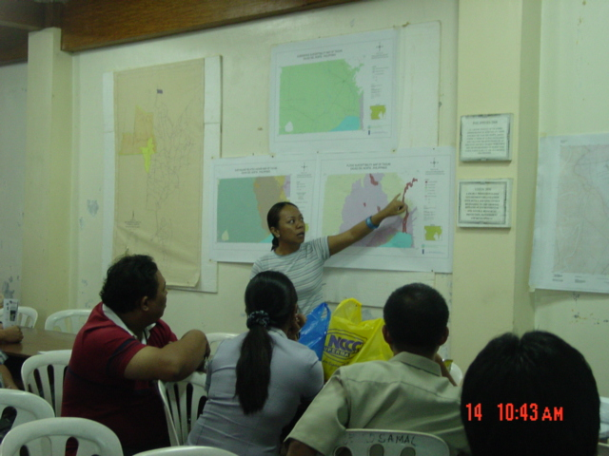

Figure 5 : Gendered IEC campaign and advocacy campaigns to promote equal access to information (Courtesy of Mines & Geosciences Bureau, DENR and ENR Shell Programme)

Figure 6 : A signage in local dialect indicating susceptibility of the sites for potentials landslides as a way of educating the community (Courtesy of Mines & Geosciences Bureau, DENR and ENR Shell Programme)

The IEC component of the project itself was an innovation since in previous similar undertaking, this is notably absent. But the conscious effort to provide equal access to information to women and men was the most important innovation in the project. By recognizing that women are badly affected by geohazards such as landslides and flood and providing with information is a way to help them cope better in times of disasters. In the context of vulnerability , providing equal access to information such as flooding and landslide susceptibility of communities may spell the biggest difference in terms of survival. This is also a way of empowering women and men, making them aware and enabling then to recognize their important roles in local disaster reduction and risk management.

Today, a gendered IEC campaign targeting local government units and communities have become an important component in disaster management programs of the government.

Paper prepared by Ms. Yolanda B Gomez, Programme Coordinator, Streams of Knowledge Foundation and Member, Gender and Water Alliance, for poster presentation during the 3rd Southeast Asia Water Forum held on October 22-27, 2007, Kuala Lumpur, Malaysia

