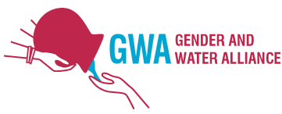
GWA Secretariat
P.O.Box 114
6950AC Dieren the Netherlands
Telephone +31 (0)313 427230
secretariat@gwalliance.org
www.genderandwater.org

GWA Approach in Bangladesh and Sustainability

The mission of GWA is to promote women’s and men’s equitable access to and management of safe and adequate water, for domestic supply, sanitation, food security and environmental sustainability. GWA believes that equitable access to and control over water is a basic right for all, as well as a critical factor in promoting poverty eradication and sustainability.

The Gender and Water Alliance (GWA) works towards better decision making at all levels by knowledge development, capacity building and awareness raising, advocacy and sharing within the network, involving her many members worldwide, supporting water professionals with gender mainstreaming.
Gender is applied in the broad sense, meaning relations between women and men, but also ethnicity, race, socio-economic differences, age, different abilities and caste. All these forms of diversity interact, and awareness about power relations helps water management to be more sustainable and effective.
What is unique to GWA is that it is the only organisation in the world and in Bangladesh that works on gender mainstreaming in integrated water resources management (IWRM). Water programmes in most countries the world over often focus on hardware and infrastructure whilst women and gender programmes hardly ever look at technological interventions and their impact on gender relations.

In Bangladesh GWA currently has 260 members (this number was 110 at the beginning of the project) of which 95 women and 165 men. These members include professors of various academia, research scientists, water engineers, gender and water experts, management staff of NGOs, and CBOs (Community Based Organisations) – all involved in integrating gender concerns in water related projects and activities. Nearly two thirds of the GWA Bangladesh members are men, and they are important allies in mainstreaming gender in water related policies, projects (including EKNsPs), and other activities in the country.

The GWAPB trainings and workshops for capacity building and knowledge development will essentially use the IWRM approach, along with participative, actor-oriented methodologies of sociology which view empowerment of water users, and especially poor women, men, and children not only as an objective but as a pre-requisite for ensuring sustainable, equitable, and efficient water management.

Relevant guiding principles and key features of the GWA approach as applied by GWAPB are included in the following conceptual framework:

IWRM Integrated Water Resource Management
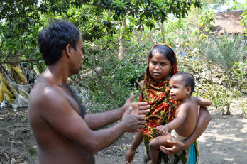
Realising the shortcomings of the IWRM approach, it nevertheless remains important to look at water management in an integrated way. Water is ever getting scarcer and many people, in fact women, in Bangladesh have a big problem finding water for their households and families, whilst too much groundwater is used for over-thirsty agricultural crops. The different water uses are interlinked and should not be looked at separately. Decision making on the use of water and its management cannot be done without taking the different stakes, needs, and interests of diverse groups of people into account. Participation of all water users, stakeholders, but also stake-losers is necessary not only to prevent conflicts over water, but also to make the best use of the available water, be it for drinking, sanitation, agriculture, other productive uses or for nature. In the Bangladesh Water Act 2013, it is clearly written that drinking water is priority number 1. Nevertheless in Bangladesh between 80 and 96 % of fresh water is used for agriculture (numbers from different sources).
Technical and social aspects of water management are equally important.
Fathers could enjoy taking care of the children too
Gender includes women and men
GWA does not only focus its work on women, but also on men. In most public sector water institutions and technical teams men outnumber women, so it has been important to build their understanding of gender relations in water management, and how Gender Mainstreaming (GM) can make their work more effective, cost-efficient, and sustainable. Men water professionals learn the importance of involving women in decision making, and thus adding to the sustainability of changing power relations. However, while addressing both men and women in CB activities, GWAPB has recognized that special support needs to be given to women in gaining the necessary skills to be able to effectively participate in decision making. Poor men are in a different position than poor women, but they also have responsibilities, difficult to fulfill with access to few resources. Men, as much as women, need to learn to understand about gender relations and the advantages of empowerment of their wives and themselves.

Gender+, Gender Plus, Gender and Diversity, Gender and Inclusion
These are all labels for gender in the broad sense to be applied for understanding power relations at all levels: relations between women and men that interact with ethnicity, race, socio-economic class, different abilities, age, etc. All this diversity, shows the richness of the differences between people, and awareness about power relations helps water management to be more sustainable and effective.

Equity is meant to reach equality
In case one category of people is left behind, equal treatment will not help them get on track, they will remain behind. For equality it is necessary to give the vulnerable and less privileged people extra support, until equality is reached.

Empowerment approach with four interacting elements
An empowerment approach has been taught and applied with four interacting elements: socio-cultural, political, economic and physical. Empowerment, especially of marginal women, but also of other categories of people, is used as an objective and a tool for analysis, monitoring, and evaluation of all our activities. This has been the core of GWAPB’s Capacity Building. Technical professionals overall find this easy, whilst in general the often promoted Gender Analysis (of Moser and Harvard) was too difficult, time-consuming and hard to make applicable to the real context.

Women are agents of change, not just victims
Women are not only victims, but also agents of change, actors in development. They have useful skills and knowledge because of their specific tasks in water management and sanitation. Only by their genuine participation, not just in work but also in decision-making, can efficient and sustainable water management be achieved. Those who are responsible for certain tasks, also should be involved in relevant decision-making.

Women are also victims, especially in disasters
Women and children are by far the majority of the victims of disasters and climate change (floods and droughts), so it is important to involve them in disaster risk management, again, not just to do the
(earth-) work, but also to make the decisions.

To operationalise these concepts and the ideas behind them, we apply the following principles:

Building on existing knowledge
The social knowledge that technical counterparts already have, is acknowledged and built on further.

Involve partners and GWA members and their expertise
GWA ensures efficiency of its activities by working in partnership with other (member) organisations. In GWAPB it is clear that all work has been together with other organisations or projects. Where possible GWAPB has applied the expertise of its members.
During CB workshop time is made for fieldvisits. This is a visit to a Proshika Credit Group, near to Koitta

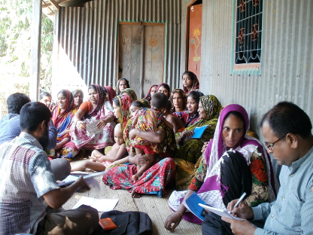
No space for patronising
GWAPB’s way of working is to show technical water professionals that gender mainstreaming is in their own interest, and that, if they want, they will get our support. In this approach there is no space for patronizing. There have been open discussions in order to learn from each other, both ways. GWA needs to know about the technical work to explain the gender relations in its context and to come together to suggestions for improvement by gender mainstreaming. That was achieved in participatory and interactive capacity building workshops, in field visits and in the meetings with EKNsPs.

Individual Gender Action Plans and Active Learning
Within its capacity building work GWAPB has applied the earlier developed methodology for active learning: water professionals are assisted and encouraged to develop an individual gender action plan (IGAP) for gender mainstreaming at their work-place, which GWAPB staff would coach when asked to. By exchanging experiences in follow-up workshops, participants learnt from each other and network amongst themselves leading to better results.

Demand driven, participatory, tailor made activities are prioritised
Effectiveness is achieved through the demand-driven, participatory and tailor-made approach GWA uses in all its activities. This has ensured ownership at the level where the activities are executed, and increases their sustainability as well.

Monitoring with few indicators
Formulation and monitoring of SMART (specific, measurable, applicable, realistic and time-bound) gender indicators is often key to the sustainability of programmes. GWAPB has contributed to quantitative and qualitative monitoring, by developing frameworks together with the EKNsPs, as well as developing some documents for gender disaggregated data collection. The indicators should be few, to make sure monitoring serves a purpose and does not become a purpose on its own. Monitoring progress in gender mainstreaming needs to be both quantitative and qualitative (inquiries).

Inquiries
Inquiries are an open form of interviewing in which the interviewee can him or herself tell what are important positive and negative aspects of their daily life or situation. There are no questionnaires, apart from perhaps a checklist with subjects. Case studies are written with literal quotes. Such inquiries and case studies are used for qualitative monitoring, by repeating them after some time.

Field visits in capacity building workshops
If time permits, it is always educative to have a field visit as part of the training workshops.

Avoid Development Jargon
In GWA communication, training and documentation we avoid development-jargon: we try to speak and write in easy language to be understood also by those whose mother tongue is not English. To speak and write easy language is not easy. Jargon is much easier, but is also an obstruction in development. Jargon hides daily realities, thus creating the possibility to deny and ignore the real problems and the real people involved.
If all in the room speak Bangla, of course the language spoken in the session will be Bangla.

Documentation
Of all activities reports have been written, as well as of team meetings. It can be said that most work has been documented.

The GWA and GWAPB approach has proved to be effective and appreciated.

Sustainability
The FIETS concept of sustainability of SIMAVI had been applied with some additions: Financial, Institutional, Ecological, Technical and Social including gender, with adding Economic and Political, coming to FIETSEP.

The GWAPB project has different aspects of sustainability, and some that are not yet sustainable. GWAPB has not yet managed to be financially sustainable, the project was, but the institution now that the project is over, is not. Institutionally GWAPB has been successful, with the NGO AB registration, and an increasingly wide and good reputation, but without the F (financial), the I (institutional) on its own is insufficient. Ecological and Technical sustainability has more relevance in the EKNsPs, not directly in GWAPB. Also Economic and Political are meant for the EKNsPs.

For the EKNsPs the GWAPB has added to their sustainability, and to that of their work in the districts. To reach critical thinking and learning, is a great and sustainable achievement, difficult to turn back. But many participants of capacity building activities have changed jobs, so within the EKNsPs the gender mainstreaming knowledge is not yet sustainable allover and needs more CB input. This can be considered Institutional (in-)sustainability. From the Final Monitoring Report of GWAPB (June 2016) by the external STE we quote:
“It is evident that GWAPB’s capacity-building activities over the three year period have had a significant impact in improving knowledge of gender and water issues among Bangladeshi professionals working in the water sector. Although many of them have left the EKNSPs with which they were employed, they have brought their newly-acquired knowledge to their new positions, thus creating a trickle-down or indirect impact of the GWAPB project.”
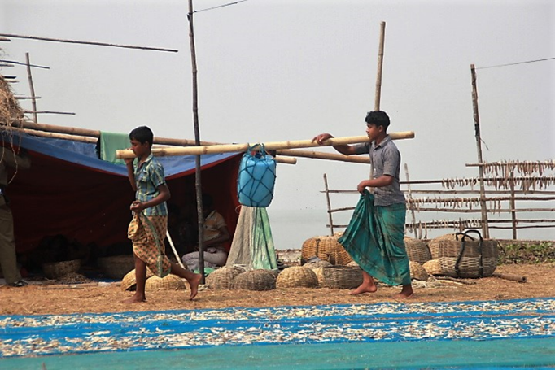
The FIETSEP indicators are all important for the beneficiaries of the EKNsPs. The development that they are experiencing in the projects will give them more income, and in case the projects work from a gender perspective, the chance that the source of income is sustainable is larger. Also the environmental and political aspects (their own organizations) are more sustainable when women and men have equal opportunities in the project. The Technical indicator is very interesting: in some of the projects there has been attention for women-friendly technologies for agriculture, for water supply and sanitation, for aquaculture, etc. Once such technologies have been developed, they are there to stay. Other organisations will see them and be inspired to copy, adapt and apply them.
Fisher boys in Dublar Char

